Peter Sanford

IT 2700  
NetLab Lab 15  
12/07/2023

1.1

Step 5:

Step 12:

Step 19:

Step 22:

Step 27:

1.2

Step 2:

Step 6:

Step 12:

Step 17:

1.3

Step 3:

Step 5:

2.1

Step 1:

Step 5:

Step 9:

Step 11:

2.2

Step 11:

2.3

Step 3:

Step 11:

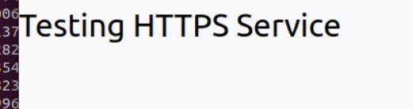

Commentary:

In this lab we looked at proxy servers and implementing secure protocols. I learned that it can be a little complicated making everything go through a proxy server but can give you a lot of control over the packets and the users. I also learned that secure protocols are a great way to increase your security without too much hassle. Knowing this information, companies can use proxy servers and secure protocols to gain more control over the security and also maintain security best practices using the most up-to-date protocols.